EECS 581
Fall 2017

Project Proposal

Team EduCare

Date submitted: 10/22/2017

Group Information
Team Name: EduCare
Team Members and Email Addresses:
- Sharynne Azhar (sharynneazhar@ku.edu)
- Erin Coots (erincoots@ku.edu)
- Neil Dunn (n768d465@ku.edu)
- Najeeb Lakhani (n381l087@ku.edu)
- Vuong Nguyen (v107n887@ku.edu)
Github Link: https://github.com/vuongptnguyen/EduCare
Team Meeting Time: Wednesdays @ 4:00PM
Lab Meeting Time: Mondays @ 11:45AM
Contact: Najeeb Lakhani and Erin Coots
Project Sponsor: N/A

Project Description
The journey of college/university is very confusing and overwhelming for many students all around the world. These students turn to programs such as advising, on-campus student activities, and clubs/extracurriculars to help them understand their interest, better define their path in their educational careers, and gain skills that will aid in their future success. But unfortunately, there are may pitfalls such as lack of involvement outside of the classroom due to lack of information on clubs/activities/events, poor advising from advisors, not actively monitoring your grades/gpa.
Our goal is to solve these problems. We are designing an application that allows student to construct a profile based off their interests (academic and personal), events they attend or want to attend, grades, and health (subject to change). This application will allow students to find events/activities/clubs based off of their interests therefore promoting engagement with the community around them. This will expose the student to the opportunities and interests they previously didn’t know they had.
The application will also allow students more comprehensive and personal advising sessions with their advisors. The advisors can view the student's profile to help understand better and thus allowing advisors to provide well informed advice tailored to the student interests.
Finally, the application will provide a central location for self-management tools such as GPA calculator and grade calculator for each class.

Project Milestones

Implementation Milestones:

First Semester:
- Phase 1: Conception and Initiation (September 2017)
- Phase 2: Design and Specification (October 2017)
- Phase 3: Implementation (November 2017)

Second Semester:
- Phase 3: Implementation (December 2017)
- Phase 4: End-to-End User Testing (February 2018)
- Phase 5: Deployment and Distribution (April 2018)

Documentation Milestones:
- Team Formation (September 2017)
- Initial Project Description (October 2017)
- Gantt Chart (October 2017)
- Project Proposal Report (October 2017)
- Project Proposal Video (November 2017)
- Final Design Document (Spring 2018)
- Final Project Video (Spring 2018)
- Quad Chart (Spring 2018)

Gantt Chart:
View the Gantt Chart here: https://drive.google.com/file/d/0B-DkWhsqmjdGdjh4N0lXdzgwREE/view?usp=sharing

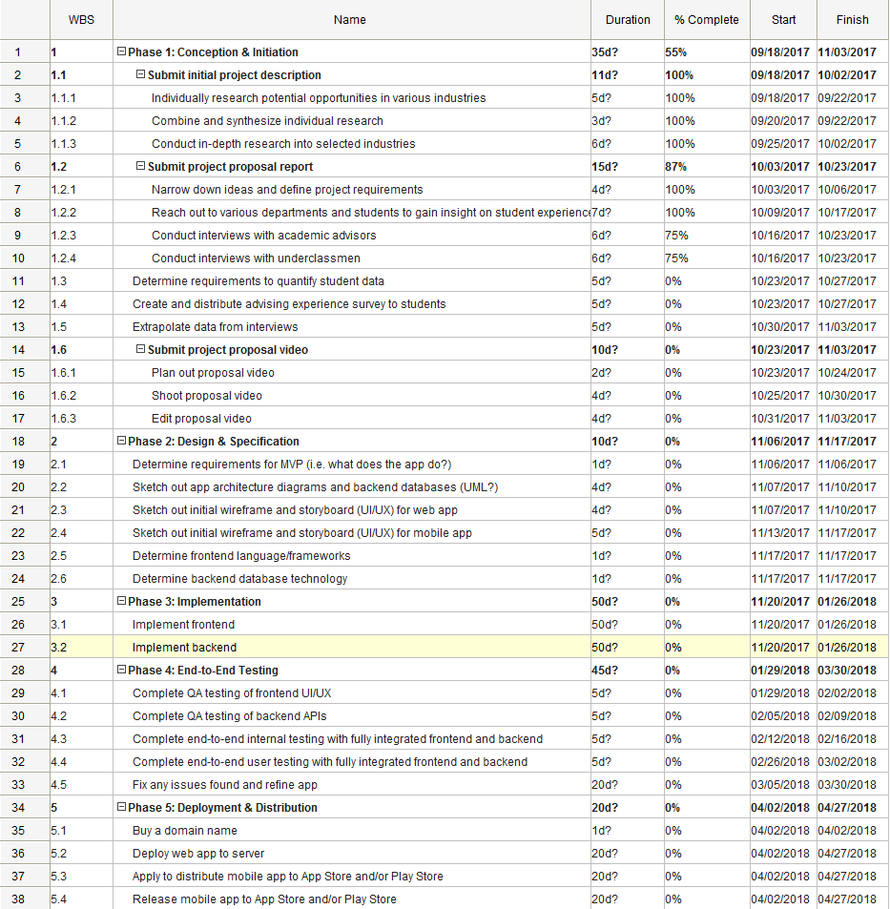
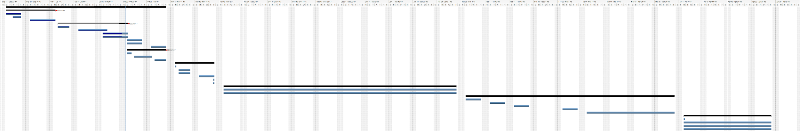

Project Budget
- Domain Name:
  - Google Domains: $12.00 per year
- Web Hosting:
  - Vendor: Heroku
  - Cost: At least $25 per month for standard plan
- Software Licenses:
  - Apple Developer Program (if iOS app): $99 per year
- Github Subscription:
  - Cost: Free until graduation; $21 per month after that
- Training Courses / Tutorials:
  - Cost: Varies based on platform

Work Plan
- Sharynne: Front-End Coder, Debugger, Team Status Reporter
- Erin: Front-End Coder, Debugger, Contact
- Neil: Coder, Debugger
- Najeeb: Back-End Coder, Debugger, Contact
- Vuong: Coder, Debugger, Team Leader

Preliminary Project Design

Abstract
The software will be presented as a web application for the academic advisors and a mobile application for the students. Since the purpose of the software is to improve retention through advising the first, obvious, user will be advisors. Advisors will have access to profiles on all their assigned students with information like the students self reported grades, previous university attendance, previous declared majors, extracurricular involvement, event interest/attendance, etc. They will also be able to view comprehensive analytics for themselves, with data on things like how many of their assigned students are passing. There will also be a user view for students. Students will be able to see a calendar of campus events, schedule appointments with their advisor, update information in their profile (grades, interests, etc.), and fill out and submit academic forms.

Figure 1. Basic Model Diagram of EduCare

Academic

Target Market:
Freshmen
Sophomores
Advisors

Teaching
in-class
homework outside class

Advising
retention

quality advising

communication

Front-End:

Web Application - Advisor:
From the perspective of the academic advisors and staff members, the web platform acts as a central dashboard who organizes and displays data about their assigned students. From the initial UX research with a number of advisors from the Undergraduate Advising Center, the intervention strategy focuses on communication between instructors to advisors, and then to students: the instructor can alert the advisors about students’ poor performances based on their class attendance and grade. From there, the advisors can conduct critical conversations with the students to address such issues, provide supports and suggest alternative resources. With this academic intervention strategy, the advisors are interested in collecting specific data that reflects the students’ in-class performances such as grade, attendance and instructor-student interactions.
However, the students’ experience in college extends beyond in-class experience. The students are living on-campus, attending social events, working on and off campus, participating in student organizations, etc. There are numerous factors that affect students’ experience and success in college. The information about the types of events or organizations that a student is involved with, or the amount of hours a student works for financial reasons, are crucial for an academic advisor because these outside factors directly affect students’ in-class performance. Currently at KU, academic advisors only have access to their students’ grade, attendance rate and enrollment information. Our web application introduces a concept that tracks students’ out-of-class experience such as the campus events and activities they participate, their interactions with their instructors and residential staff (for on-campus living), and their experience with other campus resources (dinning, writing center, etc.) In the front end of the dashboard, the advisors are able to filter certain data that they would like to know about a student.

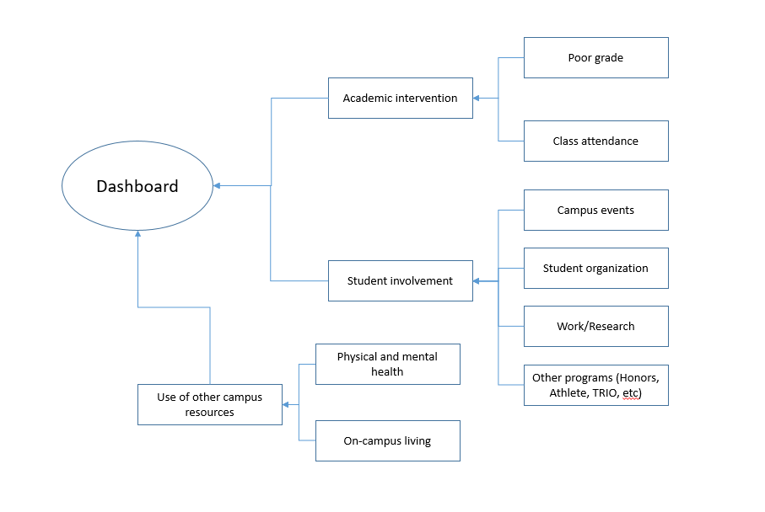
Figure 2: The dashboard provides the advisors the above information about their assigned students.

Mobile Application - Student:
From the perspective of a student, the mobile app acts a platform to drive student engagement from orientation day to graduation day. It is a comprehensive tool where students can view a calendar of campus events and activities, schedule appointments with their advisors or faculty members, and update their profile information and academic forms.
During orientation, the EduCare app will quickly connect students to campus and each other based on various factors such as field of study, hobbies, or even hometowns. From there, the app encourages continued involvement by informing students about every single event happening on campus, providing easy access tools such as a GPA calculator, and notifying them about various workshops and advising sessions available. The EduCare student app aims to continually and consistently adapt to changing interests all the way through graduation.
The student app will contain three major sections: academic management, student resources, and campus involvement. Currently, tools such as the GPA calculator and grade tracker are hard to find or are in separate websites. The app will provide quicker and easier access to these tools for students which will also be synced with the admin dashboard for their advisors to see. The app will also provide student and campus resources. For example, a simpler way to communicate with administrative and even peer advisors through the app. The app also has a list of campus organization and upcoming events at students’ fingertips. As students continue to attend events or set up appointments, the app will learn these behavior and provide better suggestions to students, maintaining engagement throughout their college years.
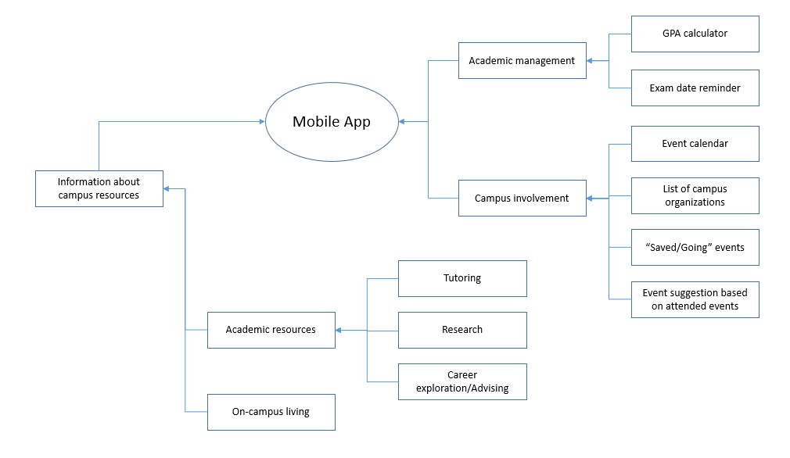
Figure 3: The student app provides students information about various campus events and resources.

Back-End
The backend will house the student profile data, event/club/activity data, student app usage data. The data will be stored in a SQL database that will either be hosted on EECS servers or a cloud service. The data will be mined to retrieve quantitative metrics in order to do the following: provide recommendations on possible event/club/activity based on past attendance, provide advisors with performance statistics of the student based off grades and surveys they will take. To mine the data we can use Apache Spark with Python. We will use modules such as numpy, mllib, and pandas and process it with Spark.
When working with along with the front end, the front end will pass queries to the backend where they will be processed and will return back an object in the desired format of the front end. The backend will be designed based on the needs of the front end. For example, the table for student profile will be only hold values that the front end of the project needs. The speed and resources will be optimized based on the need of the front end. For example, if the front end requires query-while-typing, the back end will be created so that it can return the desired result in the time requirements.

Conclusion
With these ideas of the front end, back end, and the user base in mind, this application will significantly enhance the student’s overall college experience, both academically and personally. The student will be able to keep track of their grades, calculate his/her grade point average, keep note of their interests, and overall perform better academically by using this app. Since this app will provide meaningful data from the student to the advisor, the app will boost communication between the student and advisor. The advisor will be able to give advice that is more robust and more closely tied to the student’s interest. It will be much easier for the student to maintain and keep track of his/her grades and academic schedule. The app will also notify students of all campus events that are upcoming, so they will have more opportunities to attend and make themselves involved in these events. This can greatly boost their on-campus life and give more opportunities to connections between other students. With this app providing tracking of academic progress, communication between the student and advisor, and more opportunities for the student to get involved in on-campus events, the student will have a more successful college experience.

Ethical and Intellectual Property Issues

Ethical Issues
The main concern with potential ethical issues is student privacy. The web application not only displays students’ in-class performances, but also tracks their overall on-campus experience, which include interactions with other staff members and faculty, the events the students go to, the resources they use on campus. The academic advisors may not only be authorized to view certain information. For example, if the student use a campus counseling resource for a mental health concern, the advisor knowing about this appointment will violate the student’s privacy. Also, having a central dashboard which displays all the information about a student, including academic performances, extracurricular activities, personal information and personal interactions with other people, may cause a security concern. The staff members who have access to this web application must be authorized, trained and aware of security threats to avoid information leaking.

Intellectual Property Issues
In this project we will use technology that is not developed by us. We will use location tracking tools, API’s for data visualization and data processing. Since we didn’t write the code ourselves we must take into consideration how we will give proper credit to the creators. When using code or API’s we must properly give credit by stating its source and how it was used in our program. We must also state any authorized modifications that were made to the original code. On the note of modifications, we must read through any licenses and understand any limitations to the use of the code or API. This will ensure that we don’t face any legal problems down the road.

Change Log
- Project Description - Instead of focusing on communication between students and professors in the classroom, we are now focusing on advising and on-campus life (both academically and personally). We all have a better understanding of some of the problems that arise under advising and acquisition of on-campus life, thus we feel more confident focusing on those rather than teaching and student/professor communication.
- Project Milestones - Since we now have a better idea of our project, the milestones are more specific and complete with an initial draft of our Gantt Chart.
- Project Budget - We added some potential costs that might occurs throughout development.
- Work Plan - We now have people assigned to work on the front end and back end. Our initial work plan was vague, so we needed to make sure we knew what we are doing exactly.
- We switched our field from Machine Learning to Data Mining and Data Visualization. These fields are closer tied to our current project idea.

